**ST. XAVIER’S COLLEGE**

**(Affiliated to Tribhuvan University)**

**Maitighar, Kathmandu**



**DATABASE MANAGEMENT SYSTEM**

THEORY ASSIGNMENT#9

**Submitted by:**

**Shreesha Pokharel**

013BSCCSIT038

**Submitted to:**

|  |  |
| --- | --- |
| **Er. Sanjay Kumar Yadav** |  |

Lecturer

Department of Computer Science

Date of submission: 1st October, 2015

**DATABASE RECOVERY:**

Reconstructing the contents of all or part of a database from a backup typically involves two phases: retrieving a copy of the data file from a backup, and reapplying changes to the file since the backup from the archived and online redo logs, to bring the database to a desired SCN since the backup (usually, the present).

To **restore** a data file or control file from backup is to retrieve the file onto disk from a backup location on tape, disk or other media, and make it available to the database server.

To **recover** a data file (also called **performing recovery** on a data file), is to take a restored copy of the data file and apply to it changes recorded in the database's redo logs. To recover a whole database is to perform recovery on each of its data files.

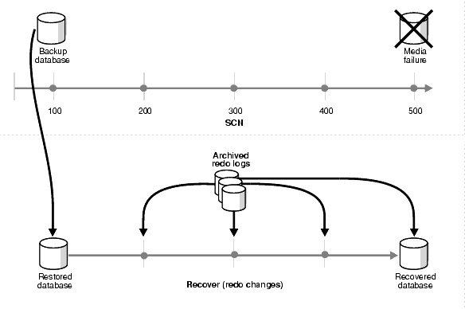

Fig: restoring and recovering a database

1. **Purpose of data recovery**

Recovery—that is, the return to a fully operational environment after a hardware or software failure—is an important process. Moreover, the effects of a system failure on the organization must be curtailed to minimize any substantial financial loss. Actions must be taken to prevent DBMS failures or resolve them quickly if they occur. It is not always cost-effective to implement all possible DBMS controls and use all known review techniques. The choice of whether or not to audit can have a direct impact on the financial consequences caused by these failures. A review of DBMS recovery ensures adherence to appropriate practices and procedures and minimizes business losses. A review further ensures that an organization can recover and return to full operational status following a disaster.

For example, the January 1994 earthquake in the Los Angeles area caused sustained interruption of business in many organizations; those organizations that had established recovery procedures were able to more readily restore operations and minimize losses. Developing, implementing, maintaining, and auditing the DBMS recover controls and processes involve a considerable amount of money and company resources. Costs and Previous benefits must be considered to ensure that company resources are expended efficiently. Systems managers who are either developing or maintaining a DBMS must understand data base structures and participate in the recovery process. This article explains the process and techniques for reviewing DBMS recovery.

1. **Types of failure**

**User Error:**

A database administrator can do little to prevent user errors (for example, accidentally dropping a table). Usually, user error can be reduced by increased training on database and application principles. Furthermore, by planning an effective recovery scheme ahead of time, the administrator can ease the work necessary to recover from many types of user errors.

**Statement Failure:**

Statement failure occurs when there is a logical failure in the handling of a statement in an Oracle program. For example, assume all extents of a table (in other words, the number of extents specified in the MAXEXTENTS parameter of the CREATE TABLE statement) are allocated, and are completely filled with data; the table is absolutely full. A valid INSERT statement cannot insert a row because there is no space available. Therefore, if issued, the statement fails.

**Process Failure:**

A process failure is a failure in a user, server, or background process of a database instance (for example, an abnormal disconnect or process termination). When a process failure occurs, the failed subordinate process cannot continue work, although the other processes of the database instance can continue.

**Network Failure:**

When your system uses networks (for example, local area networks, phone lines, and so on) to connect client workstations to database servers, or to connect several database servers to form a distributed database system, network failures (such as aborted phone connections or network communication software failures) can interrupt the normal operation of a database system.

**Database Instance Failure:**atabase instance failure occurs when a problem arises that prevents an Oracle database instance (SGA and background processes) from continuing to work. An instance failure can result from a hardware problem, such as a power outage, or a software problem, such as an operating system crash. Instance failure also results when you issue a SHUTDOWN ABORT or STARTUP FORCE command.

1. **The storage hierarchy**

Databases are stored in file formats, which contain records. At physical level, the actual data is stored in electromagnetic format on some device. These storage devices can be broadly categorized into three types −

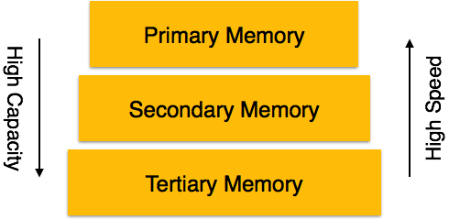

* **Primary Storage** − the memory storage that is directly accessible to the CPU comes under this category. CPU's internal memory (registers), fast memory (cache), and main memory (RAM) are directly accessible to the CPU, as they are all placed on the motherboard or CPU chipset. This storage is typically very small, ultra-fast, and volatile. Primary storage requires continuous power supply in order to maintain its state. In case of a power failure, all its data is lost.
* **Secondary Storage** − Secondary storage devices are used to store data for future use or as backup. Secondary storage includes memory devices that are not a part of the CPU chipset or motherboard, for example, magnetic disks, optical disks (DVD, CD, etc.), hard disks, flash drives, and magnetic tapes.
* **Tertiary Storage** − Tertiary storage is used to store huge volumes of data. Since such storage devices are external to the computer system, they are the slowest in speed. These storage devices are mostly used to take the back up of an entire system. Optical disks and magnetic tapes are widely used as tertiary storage.

1. **Buffer management**

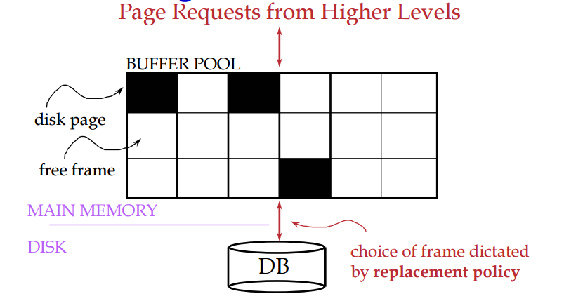

Data must be in RAM for DBMS to operate on it. Buffer Manager hides the fact that not all data is in RAM.

1. Transaction management
2. Data updates
3. Data caching
4. Transaction roll back (undo) and roll forward
5. Check pointing, shadow paging
6. Recovery schemes (WAL: Write Ahead Logging Protocol)
7. Failure with loss of non-volatile storage (General Concepts)
8. Recovery in multi-database